Operational Research Tutorial
  - Networks – Minimum Spanning Tree and Shortest Paths

Algorithms

Minimum Spanning Tree

Prim’s
- Initialise distances to vertices as $∞$ and predecessors as $-$
- Arbitrarily select a vertex and label as selected
- Update distances and predecessors to adjacent unselected vertices
- Select the reachable vertex with minimum distance
- Repeat 3 and 4 until all vertices have been selected
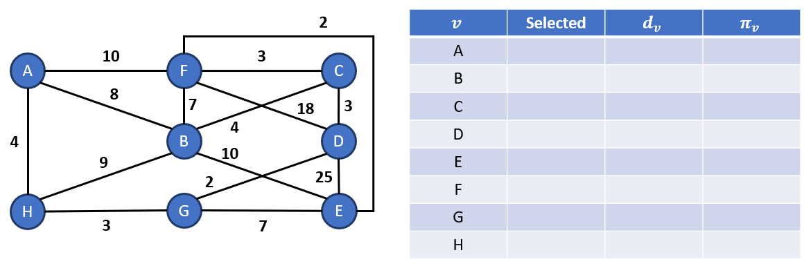

Kruskal’s
- Order the edges by weightings, lowest to highest
- Select the lowest-weight edge not yet considered; if it does not form a cycle, label it as selected
- Repeat step 2 until (number of vertices − 1) edges have been selected
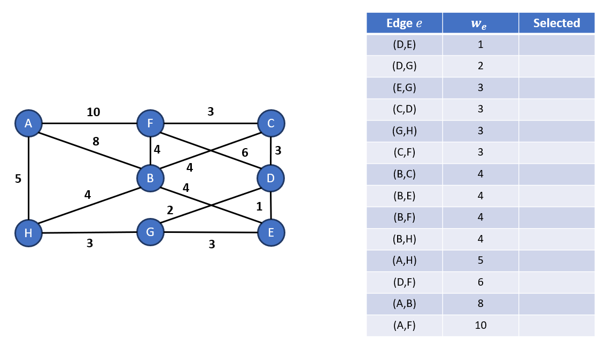

Shortest Path

Dijkstra’s
- Initialise the network, source vertex has a distance of 0 and all other vertices a distance of $∞$, label all vertices as temporary
- Label the vertex with minimum distance as permanent
- Update the distances and predecessors to reachable temporary vertices from the current permanent vertex
- Repeat steps 2 and 3 until all vertices are marked permanent
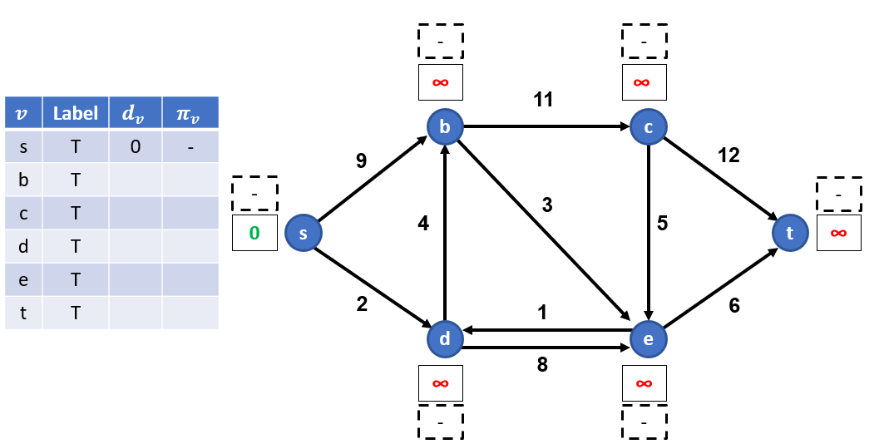

Exercises
- For the following network compute the minimum spanning tree using Prim’s and Kruskal’s Algorithms.
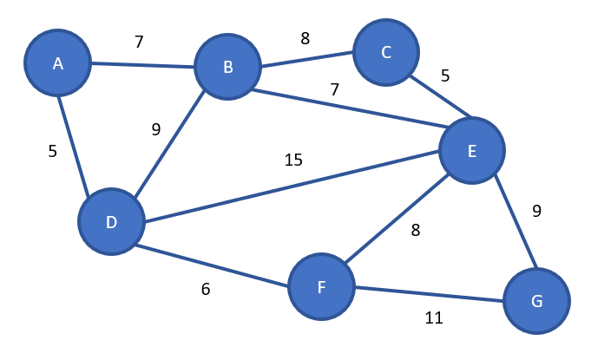

- For the following networks:
  - Compute the shortest path using Dijkstra’s algorithm from node 1 to node 4, state the path and its length.
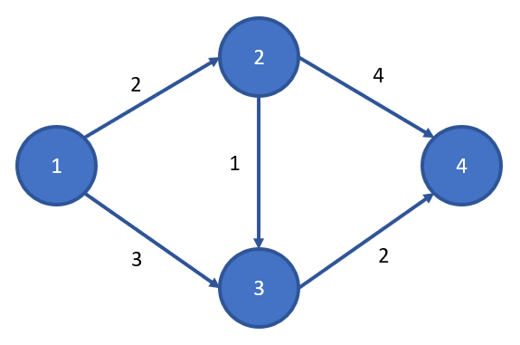
  - Compute the shortest path using Dijkstra’s algorithm from node 1 to node 2, state the path and its length.
